**Robot Simulators and how they are used in education**

For this project the robot simulator that has been decided for us to create our teaching materials about is V-REP, which is a free piece of software that boasts an impressive amount of features but to try and get a better of idea learning how to use said software as well as trying to help others learn it would be very useful to look into some of the other ones available. A big reason for this would be trying to find Simulators that are not only widely used but also used for educational purposes so that we can identify areas within the programs that will for the most part carry from one to the other, which is scene often with programs that have similar functionality like in 3D modelling and photo manipulation software where lots of tools and interfaces make going from one to the other much more simple that expected.

Here are a couple of the different simulation software I have looked into:

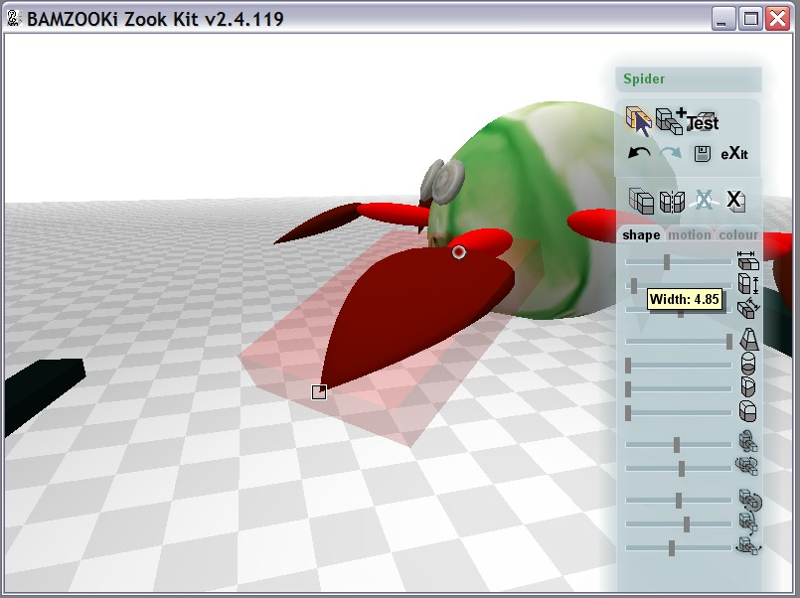**Bamzooki**

A very different kind of program to V-REP, I felt like I had to look into this software because when I was younger it was what introduced me to robot simulation software. Bamzooki was a CBBC children’s television game show that consisted of teams of 3 or 4 children creating a robot/creature called a ‘zook’ to go through various events and competing with other teams to win. A program called the ‘Bamzooki zook kit’ was released alongside the show to allow people to try and have a go at creating their own and become a potential contestant on the show.

In terms of the program itself it does have very limited options since all robots use a standard Braitenberg architecture meaning that the ai isn’t all that customizable but it was more about creating the movement patterns; design and general proportions of the creature to try and make it as mobile and balances as possible so that it would be able to win events such as races or tugs of war. Yes this is a very simple robot simulation program but in terms of education I feel it was a valuable asset in teaching many children the basics and giving them some kind of starting point to go from with its simplicity of use but with lots of options to test and mess around with. The program is quite old now and outdated so none of the functionality would really carry over but I do like its ideas and ambition at the time.

**Gazebo**

When I went to search for information about robot simulators the top result that appeared would be ‘Gazebo’ (followed by V-REP). This simulator is much more ambitious and technical than the ‘Bamzooki zook kit’ and is on par with most modern simulators including V-REP, but from what I have seen from it the program seems to lack a lot of the functionality of V-Rep just by looking at the GUI alone.

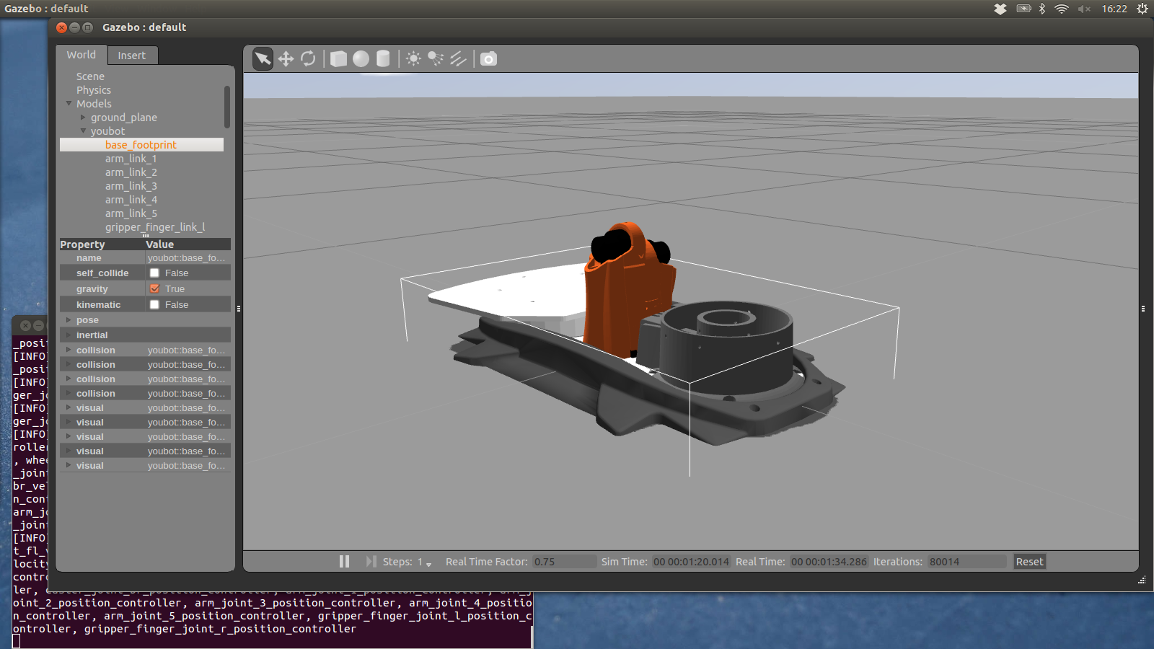

Something that surprised me when I was researching this software was that it was currently not available for windows platforms which according to the site is still being worked on, instead the main platforms its available to are for Linux which means that it is unfortunately not as widely available as I had hoped it would be and would definitely be a problem if it were considered for educational use considering the majority of users would be using a Windows or Mac based operating system and would have trouble accessing and learning the program. I found this quite unfortunate because looking at the site it has some great tutorials and documentation, going from the basics to some more advanced options and I found this to be a great feature, it even included tutorials for some of the specific versions of the program.